**Comparative Analysis Sales Dashboard**

**Read Data**

Upload the data in the Power BI.

Data Tab
**Date Dimension**

Create a Date Dimension Table. Click on the Table/Data tab at the left.

Then Click on New Table  
Create a new table called Date Dim and use CALENDARAUTO() function.

The Calendar Auto Functions takes the dates from the uploaded data automatically.

Create Year, Month and Quarter Columns.

Go to the Model and connect the Date Dim with the other tables

Now inside the model, we can hide the columns which we do not need. In my case, I’m not hiding them because I want to keep them for now.

**Page Background Adding**

**Creating a new Measure** (CY SALES = Current Year Sales)

So we have created a variable called CY Sales (Current Year Sales)

CY Sales = (This is basically the name of the measure)  
Var CY = MAX(‘Date Dim’[Year]) # If in the slicer we have not selected the year it will automatically take the maximum year.

Return

CALCULATE(SUM(Sales[Sale Amount]), ‘Date Dim’[Year] = CY)

PY Sales = CALCULATE([CY Sales]),SAMEPERIODLASTYEAR('Date Dim'[Date] ))

Whatever period we are taking the CY Sales, we will get the same period last year in PY sales.

**Creating a new measure YoY Growth%**

YoY Sales Growth% = Divide([CY Sales]-[PY Sales],[PY Sales],BLANK())

Blank() is the alternate result. It is used in case we get an error. Divide by 0 will result in an error.

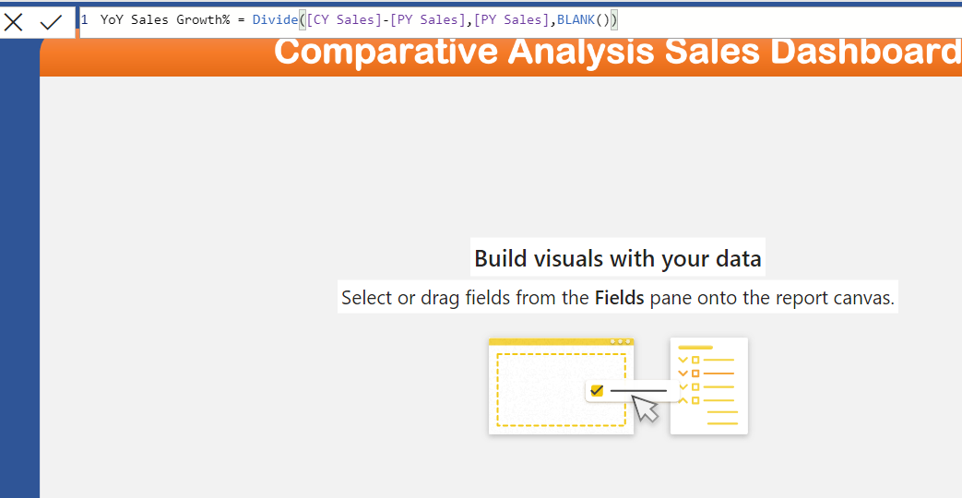

**Creating a new measure for Budgeted Sales**

Budgeted Sales =

Var CY= MAX('Date Dim'[Year])

Return

CALCULATE(Sum(Budget[Budgeted Amt]),'Date Dim'[Year]=CY)

Change the percentage value to percentage

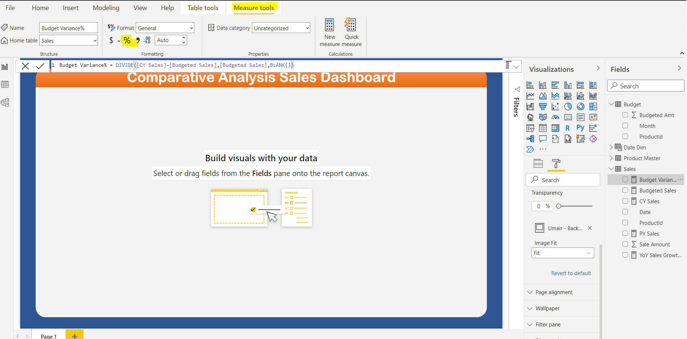

Selected 4 cards on the left. Select all and then group them to change their sizes together.   
Select All – Go to Format – Group

Labelling the data values by colour

Select the card – Go to Visualization 🡪 Format 🡪 Data Label 🡪 click on **fx** under the colour heading.

Replicating Formatting (Data Label coloring as well)  
Select the original card, click on format painter, and then click on the visualization you want to format like that.

Remove the Header (title) of the slicer table. Go to Format 🡪 Header 🡪 power off header

To make the date filter so cleanly formatted like this.

* Make the slicer drop down
* Go to format – Disable Background
* Go to Item, change the background colour to white.

Formatting CY Sales by Category Chart

* Title background blue
* Title font color white
* Center align
* Font Family to seoge

Date sorting important. We created a new column called date month no. Once that is created we select the month column and then we sort it by the column month no. And in the charts the dates will be automatically sorted.

When we are adding the date column, we can click right-click on it and remove the Date Hierarchy if we want to.

* This table chart is basically called the **MATRIX CHART.** It is so easy to make!
* Select the Style to Minimal.
* Get a Background for column headers
* Use the font color white and make it bold

Set the stepped layout to OFF (Found inside Row headers). When we drill down in the chart, we will have the new values on the new column. See when + was clicked on Cat 1 , the product name appeared a new column.

Change the background colour for the **subtotal** and the **grand total** so that it is easily identifiable and readable.

We use the field formatting and change the display unit to get the values in millions. Without doing that, the sales were coming as big numbers which were difficult to read.

**Condition formatting (Getting the shapes along with the tablular values in Matrix Chart)**

To get the arrows/KPI’s in matrix. We can go to conditional formatting and then form there we can select the shapes.

**Proper Filtration**

When we click on the value of one chart, the rest of the chart also gets filtered. Now the issue is the way they get filtered. On the remaining charts, the remaining parts get transparent leaving only the selected value.   
  
This is messy filtration. What we need is that when we click on a value, then only the selected parts and full view for that is shown on the graphs.

For this we select the chart, and then go to Format and click on **Edit Interactions**

When you click on edit interaction, then also click on the filter values.

Better view now

Tool Tip – Displaying the charts within the chart when hovering over it.

* Create a new sheet. Call it ToolTip.
* Go to page size, and select the page size to either tool tip, or make a custom size as per your specifications. In the custom for this dashboard, the selected size is Width = 250 and Height = 350.

Remove the X axis

Turn on the Data Labels

Remove the Y axis title

The product names are not clearly visible. So for this, Go to y axis, max size 50%.

* Once this is done, go to the chart where we want to have that toottip in the main dashboard
* Click on format, Turn on tool tip and select this page name.